Build From Source

For Windows Systems

--------------------

1. git clone <https://github.com/codezonediitj/adaboost>

2. Move to back to parent directory, `cd ../`

3. Execute, `mkdir build-adaboost`

4. Execute, `cd build-adaboost`

5. Install CMake from - <https://cmake.org/download/>

- After downloading locate the CMake bin folder and copy it's address

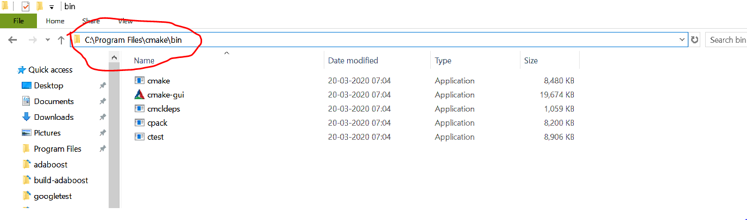

- In the search bar on task bar type environment variables. Then click on the edit the system variables

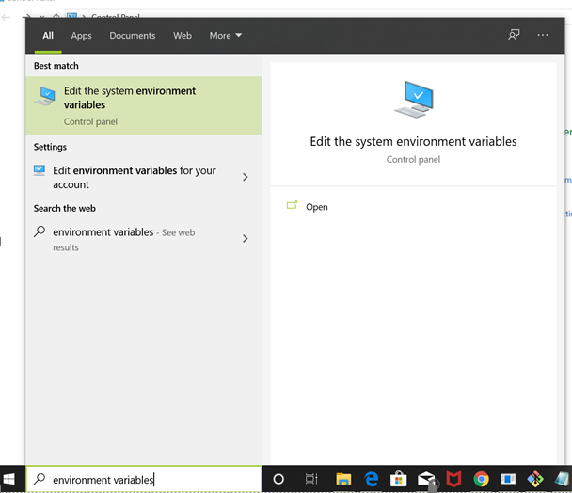

- The following dialog box will open, click on environment variables.

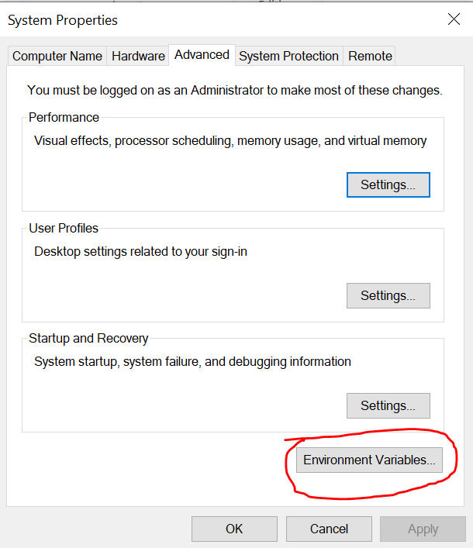

- Click on 'Path' under system variables as highlighted in the following picture. Then click 'Edit' under the same.

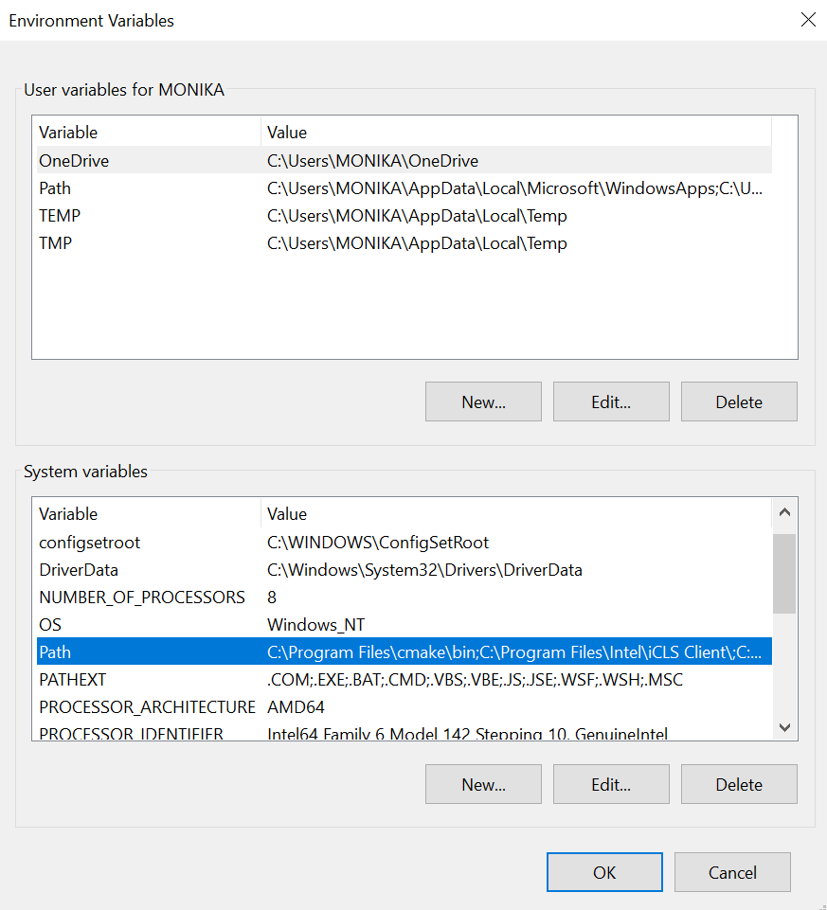

- The following dialog box will open, Click new and add the copied address of bin folder. Then Click ok.

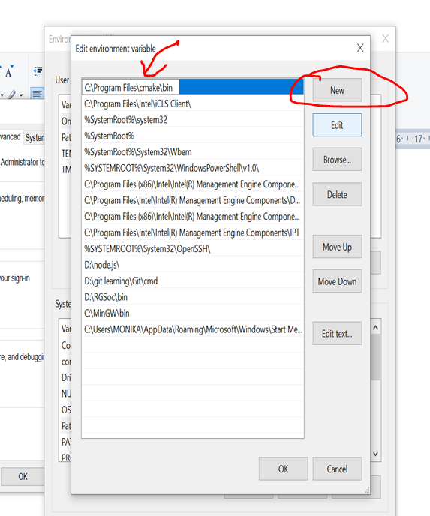

- Similarly add the paths to your compiler (for example - if it's MinGW add path to its bin folder for instance C:\MinGW\bin)

Also add path to the IDE used.

- To check that installation is done properly

run: 'cmake --version' on git bash.

It should give you the version of cmake as the output.

6. Open cmake GUI and put the adaboost directory as source code and build-adaboost directory in the build binaries field as shown in the following picture.

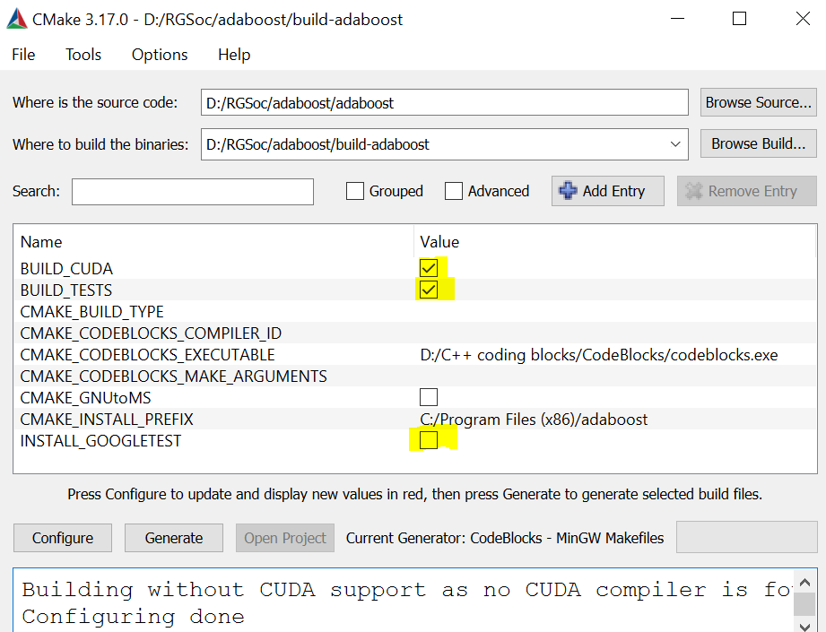

7.By default 'BUILD_TESTS','BUILD_CUDA' are turned off, you can check these options if you want to perform tests and want CUDA support , then click configure and generate to build the files .

8.Before checking the 'BUILD_TESTS' field , install google test from :- <https://github.com/google/googletest> and build it using CMake.

9. For CUDA support you need to have a CUDA compiler and you should add it's path to environment variables.